

**DEDAN KIMATHI UNIVERSITY OF TECHNOLOGY**

**SCHOOL OF COMPUTER SCIENCE AND INFORMATION TECHNOLOGY**

**DEPARTMENT OF COMPUTER SCIENCE**

**Bachelor of Science in Computer Science**

**2.3 (Internal Attachment)**

**Youth SACCO Management System**

GROUP MEMBERS**:**

**Jennifer Akinyi Ouma:C026-01-2197/2021**

**MaryAnn Wangechi Koome:C026-01-1010/2021**

**Grace Wambui Nderitu:C026-01-0999/2021**

**TABLE OF CONTENTS**

Table of Contents

ACKNOWLEDGEMENT 6

ABSTRACT 7

CHAPTER ONE: INTRODUCTION 8

1.1: Background of study 8

1.2: Problem Statement 9

1.3: OBJECTIVES 10

1.3.1: General Objective 10

1.3.2: Specific objectives 10

1.4: Research Questions (Hypothesis) 11

1.5: JUSTIFICATION 12

1.6: Scope of Study 13

1.7: Significance of the study 13

1.8: Delimitations 14

1.9: Summary 15

CHAPTER TWO: LITERATURE REVIEW 16

2.1: INTRODUCTION 16

2.2: REGIONAL PERSPECTIVE OF YOUTH SACCOS 16

2.2.1:Advantages of the system 17

2.2.2:Disadvantages of the system 17

2.2.3:Design methodology 18

2.3:LOCAL PERSPECTIVE 18

2.3.1:General characteristics 18

2.3.2:Advantages 19

2.3.3:Disadvantages 19

2.4:Design methodology 20

2.5:SWOT ANALYSIS 21

2.5.1:Strengths: 21

2.5.2:Weaknesses: 21

*2.5.3:Opportunities* 21

2.5.4:Threats: 22

2.6:Research gap 22

CHAPTER THREE: RESEARCH METHODOLOGY 23

3.1Introduction 23

3.2 System Methodology 23

3.3: Research Design 25

3.4: Data collection 26

3.5: Population 26

3.6: Sample size and Sample Procedure 26

3.7: Cost benefit analysis 26

3.8: Data collection tools 27

3.8.1:Administering questionnaire 27

3.8.2:Document analysis 28

3.8.3:Observation 28

3.8.4:Interview 28

3.9:TEST,RETEST AND DATA RELIABILITY 29

3.9.1: testing and reliability of the tools 29

3.9.2: presentation of data 29

CHAPTER FOUR: SYSTEM ANALYSIS AND DESIGN 30

4.1:INTRODUCTION 30

4.2:REQUIREMENTS 30

4.2.1:Functional Requirements 30

4.2.2:Non-functional Requirements 30

4.3:Process design 31

4.3.1:Usecase Diagram 31

4.3.2:Activity diagrams 31

4.3.3:Flowchart 34

CHAPTER FIVE: TESTS AND RESULTS 37

5.1:INTRODUCTION 37

5.2:FUNCTIONAL TESTING 37

5.2.1:TEST CASE 1 37

5.2.2:TEST CASE 2 38

5.2.3:TEST CASE 3 38

5.2.4:TEST CASE 4 39

CHAPTER 6:IMPLEMENTATION AND DEPLOYMENT 40

6.1:Introduction 40

6.2: Data conversion 40

6.3: Implementation Strategy 40

6.4: System Specification 40

6.41: Hardware requirements 40

6.42: Software requirements 40

6.5: Support and Training 41

Chapter 7: Conclusion and Recommendation. 42

7.1:DISCUSSION 42

7.2:Limitations 42

7.3:Recommendation. 42

7.4:Conclusion. 43

APPENDIX 44

Technical Requirements 44

Hardware requirements 44

Software requirements 44

Project Timeline 44

Budget Cost Estimate 44

**LIST OF FIGURES**

Figure 1:WATERFALL MODEL 23

Figure 2:USECASE DIAGRAM 31

Figure 3:SACCO MEMBER ACTIVITY DIAGRAM 32

Figure 4:SACCO ADMINISTRATOR ACTIVITY DIAGRAM 33

Figure 5:FLOWCHART 1 35

Figure 6:FLOWCHART 2 35

Figure 7:FLOWCHART 3 36

Figure 8:SUCCESSFUL REGISTRATION 37

Figure 9:SUCCESSFUL LOGIN 38

Figure 10:SUCCESSFUL LOAN APPLICATION 39

# ACKNOWLEDGEMENT

We would like to express my sincere gratitude and appreciation to all those who have contributed to the successful completion of this project. Firstly, we would like to thank our trainers, Mr. Mburu and Mr. David, for providing us with valuable guidance, feedback and support throughout the project. We are also grateful to my classmates for their insightful feedback, encouragement, and suggestions.

We would like to acknowledge the support and cooperation provided by the school administration, library staff and other resources used in the project. Their support and cooperation have been a great source of motivation for us.

# ABSTRACT

Jiinue Youth Sacco aims to establish a financial cooperative organization specifically targeted towards empowering and uplifting the youth community. The project aims to provide a platform for young individuals to save, access credit facilities, and develop financial management skills in a supportive and inclusive environment.The project will involve the creation of a youth-focused SACCO, which will be managed by a team of dedicated professionals with experience in financial management and cooperative governance. The SACCO will provide a range of services, including savings accounts, credit facilities, financial literacy training, and business development support, tailored to the unique needs and challenges faced by the youth.It will involve extensive market research, feasibility studies, and strategic planning to ensure its viability and sustainability. The project team will also develop robust governance and risk management systems to ensure transparency, accountability, and prudent financial management.The anticipated outcomes of the youth SACCO project include increased financial literacy among the youth, improved access to credit for productive purposes, enhanced entrepreneurial skills, and economic empowerment of the youth community. The project will also contribute to the overall socio-economic development of the region, by promoting financial inclusion, job creation, and community empowerment.

# CHAPTER ONE: INTRODUCTION

## 1.1: Background of study

Jiinue Youth SACCO is a SACCO founded in Mathari Sub-county for the youths between 18-35 years old. The youths are able to join the SACCO by paying a non-refundable registration fee of 1000 shillings and a minimum of 500 shillings savings a month. After six months they are able to borrow a loan of different types that is emergency, short, normal or development loan. The loans are of different interest rates per month. The loans also have different repayment periods. Loans kept in the bank as fixed deposit acquire an interest rate of 0.6% per month. To borrow a loan, the member must have three guarantors.

If a member wants to exit, the notice should be given one month prior. Dividends are shared at the end of the month depending on the amount of shares one has in the organization.

The existing process being used to register new members is a manual process where there are given paperwork to fill in their details.The same method is used when applying loans and any other process required in the SACCO.The paper work are stored individually in files for each member.

## 1.2: Problem Statement

Jiinue Youth SACCO is based in Mathari Sub-county and it is impossible for members to access services outside the region. It will be uneconomical to open other branches so as to cater to every move of the members. This problem has affected members that leave Mathari Sub-county for business or commute to other places for work and others also may decide to move from Mathari. These problem impact members when they want to access their funds in another region.

The time for service delivery is a lot. The delayed services are due to the existing use of manual processes. This problem occurs mainly during registration and loan approvals. This service inconvenience depreciates the value or importance of the service offered to the members. The problem affects members that are looking to get emergency loans and end up getting the loan late despite its purpose to solve an urgent problem.

Reporting and data management challenges is a problem that stems mainly from the use of manual processes. It is a challenge for the SACCO executives to access the reports at their convenience. It involves going through cumbersome paperwork. The summary is important during yearly financial evaluations needed when also dividing dividends among the members.

Bad loan and defaulters due to the long processes involved in paying loans. The process in place requires the members physically show up to pay up the loan. On visiting the SACCO they are met with long queues that may be discouraging to some and they may choose to go and deal with other businesses rather that spending most of their time in the queue. The SACCO must also be able to access previous financial overview of members to know their capability to repay borrowed loan without default that is made difficult with the existing process.

Stiff competition from players in the financial service industry. Other financial service industries such as commercial banks, microfinance institutions and digital lenders have established themselves in the industry. With example of digital lenders, the offer instant loans that may be a preference to many youths. This problem will take out targeted audience. This will impact the money flow in then SACCO with minimum members and little money to run the SACCO.

Lack of good communication between the management and the members in the SACCO that may be seen as complicated by the members. There may be changing regulation or information that is needed to be passed to the members. Having an electronic system will help elevate this problem and breach the gap between the management and the members.

## 1.3: OBJECTIVES

### 1.3.1: General Objective

Creation of an efficient electronic system for Jiinue SACCO that will provide SACCO services to customers and ensure good management within the SACCO.

### 1.3.2: Specific objectives

1. Use of electronic and automated processes for registration and loan approvals for customers.
2. Creation of an efficient database management system to store and manage customer and SACCO records.
3. Creation of social media platforms to help in marketing the SACCO and in communication between customers and management.
4. Creation of a digital payment system (mobile banking) to make loan repayment more efficient.
5. Creation of a check-off system for employed customers that allows loans to be payed diretly from the employer.
6. Mobile banking solution with instant loan capabilities.

## 1.4: Research Questions (Hypothesis)

1. How can Jiinue Youth SACCO services be availed to all its customers irrespective of their location?
2. How can service delivery become faster and more efficient?
3. How can customers pay loans without going to physical branches?
4. How to improve communication between SACCO members and management?
5. How to improve record keeping and management in the SACCO?
6. How to market the SACCO?
7. How to counter competition from other finance industries?

## 1.5: JUSTIFICATION

This electronic management system will create a solution to many of the problems that the current existing system is experiencing. It will also increase the productivity of the SACCO and its employers by making work much more efficient.

Improved customer experience which will eventually lead to increase in number of customers.

Reliability and easy retrieval of SACCO records whenever required.

Increased outreach due to digital marketing and better communication between customers and management.

## 1.6: Scope of Study

Financial inclusion: The study could investigate the role of youth SACCOs in promoting financial inclusion among young people. This could involve examining how youth SACCOs help to address financial exclusion and whether they provide access to financial services and products that are tailored to the needs of young people.

Financial education: The study could explore the impact of youth SACCOs on financial education and literacy among young people. This could involve examining the types of financial education provided by youth SACCOs, the effectiveness of these programs, and the extent to which they promote financial decision-making among young people.

Youth entrepreneurship: The study could investigate the role of youth SACCOs in promoting youth entrepreneurship. This could involve examining how youth SACCOs provide financing, mentoring, and support to young entrepreneurs, and the impact of these services on the success of their businesses.

Social capital: The study could explore the role of youth SACCOs in promoting social capital among young people. This could involve examining the social networks and relationships that are built through participation in youth SACCOs, and how these networks and relationships contribute to the success of young people in their personal and professional lives.

Organizational performance: The study could investigate the organizational performance of youth SACCOs, including their financial sustainability, member satisfaction, and social impact. This could involve examining the factors that contribute to the success of youth SACCOs, and the challenges they face in achieving their goals.

## 1.7: Significance of the study

The SACCO system is have a significant impact on the lives of young people in several ways such as:

Provision of access to financial services for young people who may not have access to traditional banking services due to lack of collateral or credit history. This can be especially important for young people in Mathari who are starting their careers or businesses and need financial support to get started.

Savings and Investment - By joining this SACCO, young people can develop a culture of savings and investment. They can save regularly, and this can be a way to build capital for personal or business projects.

Social Capital - The SACCO members can build social capital by connecting with other young people with similar interests and goals. This can lead to networking opportunities, mentorship, and support.

Empowerment - The SACCO can empower its members by giving them a voice in decision-making and a sense of ownership in the organization. This can help them to build confidence and leadership skills that can benefit them in their personal and professional lives.

## 1.8: Delimitations

To ensure that the research remains focused and manageable, here are some potential delimitations to consider:

Geographic location: The study focuses on Mathari sub location.

Age range: The age range for members that can register is 18-35.

Type of SACCO: The SACCO is youth-focused.

Research method: The study will use the case study research method.

## 1.9: Summary

The youth SACCO system emphasizes the importance of sustainability and ethical practices, with a commitment to investing in projects that benefit the community and the environment. The proposal suggests that the youth SACCO system will be self-sustaining, with profits being reinvested to benefit its members.

Overall, the youth SACCO system aims to provide a platform for young people to access financial services, build financial literacy, and empower them to achieve their financial goals.

# CHAPTER TWO: LITERATURE REVIEW

## 2.1: INTRODUCTION

Youth SACCOs are becoming increasingly popular in many countries, particularly in developing countries, where young people often have limited access to financial services.

## 2.2: REGIONAL PERSPECTIVE OF YOUTH SACCOS

Here is an example of a case study on the regional perspective of youth SACCOs:

*Case study*: The development of youth SACCOs in Tanzania.

Its core objective was to explore the development of youth SACCOs in Tanzania and their impact on financial inclusion and youth entrepreneurship. A case study approach was used, including interviews and focus group discussions with representatives of youth SACCOs, government officials, and other stakeholders involved in youth development in Tanzania. The study found that youth SACCOs have played an important role in promoting financial inclusion and entrepreneurship among young people in Tanzania. The government has provided support for the development of youth SACCOs through policies and regulations that facilitate their establishment and operation. Youth SACCOs have been successful in providing access to financial services and support for young entrepreneurs, and many members have started or expanded their own businesses with the help of loans and training programs offered by the SACCO.

Challenges facing youth SACCOs in Tanzania include limited access to funding and resources, lack of financial literacy and business skills among young people, and limited awareness and understanding of the benefits of SACCOs among potential members.

The study concluded that youth SACCOs have the potential to play a significant role in promoting financial inclusion and entrepreneurship among young people in Tanzania, but there is a need for increased support and resources to ensure their sustainability and effectiveness.

*General features*

1. Targeted at young people - the youth SACCOs in Tanzania are specifically designed to meet the financial and entrepreneurial needs of young people aged 18 to 35 years old.
2. Cooperative structure - the youth SACCOs in Tanzania operate as cooperatives, where members pool their resources to provide financial services to one another. This cooperative structure allows for a more democratic decision-making process and a shared ownership of the SACCO.
3. Financial services - the youth SACCOs in Tanzania offer a range of financial services, including savings accounts, loans, insurance, and other financial products.
4. Entrepreneurship support - in addition to financial services, the youth SACCOs in Tanzania also offer entrepreneurship support, such as business development services, training programs, and mentorship opportunities.
5. Regulatory framework - the youth SACCOs in Tanzania operate within a regulatory framework established by the government through the Tanzania Cooperative Development Policy (2012) and the Cooperative Societies Act (2003).
6. Government support - the government of Tanzania provides support for the development and growth of youth SACCOs, including funding, technical assistance, and policy and regulatory support.
7. Challenges - some of the challenges facing youth SACCOs in Tanzania include limited access to funding and resources, low levels of financial literacy among young people, and limited awareness and understanding of the benefits of SACCOs among potential members.

## 2.2.1:Advantages of the system

The advantages of this case study on the development of youth SACCOs in Tanzania include:

1. In-depth understanding - the case study provides a detailed and in-depth understanding of the development of youth SACCOs in Tanzania, including their impact on financial inclusion and youth entrepreneurship.
2. Contextualized findings - the findings are specific to the Tanzanian context, providing insights into the unique challenges and opportunities facing youth SACCOs in this particular region.
3. Mixed-methods approach - the use of interviews and focus group discussions with a range of stakeholders provides a comprehensive understanding of the perspectives and experiences of different groups involved in youth SACCO development in Tanzania.
4. Practical recommendations - the study provides practical recommendations for improving the effectiveness and sustainability of youth SACCOs in Tanzania, including increasing access to funding and resources, providing financial literacy and business training for young people, and raising awareness about the benefits of SACCOs among potential members.
5. Potential for replication - the findings and recommendations of this case study could be useful for other regions interested in developing youth SACCOs and promoting financial inclusion and entrepreneurship among young people.

## 2.2.2:Disadvantages of the system

The potential disadvantages of this case study on the development of youth SACCOs in Tanzania include:

1. Limited generalizability - the findings of the case study may not be generalizable to other regions or countries due to the unique context and characteristics of youth SACCOs in Tanzania.
2. Subjectivity - the case study relies heavily on subjective data collected through interviews and focus group discussions, which may be influenced by the researcher's bias or the participants' perspectives.
3. Limited scope - the case study may have a limited scope, focusing on a particular aspect or dimension of youth SACCO development in Tanzania, and may not capture the full range of factors influencing their effectiveness.
4. Lack of quantitative data - the case study may lack quantitative data, which could limit the ability to draw statistically significant conclusions and make more generalizable recommendations.
5. Difficulty in replicating - due to the specific context and factors involved in youth SACCO development in Tanzania, it may be difficult to replicate the findings and recommendations of this case study in other regions or countries.

## 2.2.3:Design methodology

It is imperative to note that there may be multiple design methodologies used by different organizations or groups in Tanzania. Here is an overview of the general design methodology used in the development of youth SACCOs in Tanzania:

1. Needs assessment:
2. The first step in the design methodology is to conduct a needs assessment to determine the specific financial and entrepreneurial needs of young people in Tanzania.
3. Stakeholder consultation:
4. The needs assessment is followed by a consultation with a range of stakeholders, including young people, community members, financial institutions, and government officials, to gain a deeper understanding of the challenges and opportunities facing youth in the country.
5. Design and development:
6. Based on the needs assessment and stakeholder consultation, the youth SACCOs are designed and developed to provide tailored financial services and entrepreneurship support for young people in Tanzania.
7. Pilot testing:
8. Before the youth SACCOs are fully launched, they are typically pilot tested in a small number of communities to evaluate their effectiveness and identify any issues that need to be addressed.
9. Rollout and expansion:
10. Once the youth SACCOs have been pilot tested and refined, they are rolled out and expanded to other communities and regions in Tanzania to increase their reach and impact.
11. Monitoring and evaluation:
12. Ongoing monitoring and evaluation are conducted to ensure the effectiveness and sustainability of the youth SACCO system in Tanzania, and to identify areas for improvement or refinement.

## 2.3:LOCAL PERSPECTIVE

*Case study:* The study by Mumo and Okello focused on youth SACCOs.

This study in Kenya found that youth SACCO members had higher levels of financial literacy than non-members, and that being a member of a youth SACCO increased the likelihood of young people starting their own businesses. The youth SACCOs studied in this research were designed to promote financial inclusion and entrepreneurship among young people in Kenya. The SACCOs provided a range of financial services, training, mentorship, and networking opportunities to their members, aimed at improving their financial and entrepreneurial capabilities.

### 2.3.1:General characteristics

1. Membership - youth SACCOs were designed to cater to the financial needs of young people, typically between the ages of 18 and 35 years.
2. Ownership and governance - the SACCOs were owned and governed by their members, who elected their leaders and participated in decision-making processes.
3. Products and services - youth SACCOs offered a range of financial services to their members, including savings, loans, and insurance. The services were designed to be affordable and accessible to young people.
4. Training and mentorship - the SACCOs provided training and mentorship programs to their members, aimed at improving their financial literacy, business management skills, and entrepreneurial capabilities.
5. Networking - youth SACCOs provided a platform for young people to network and share business ideas. This enabled the members to learn from each other and create new business opportunities.
6. Challenges - youth SACCOs faced several challenges, including a lack of financial resources, inadequate governance structures, limited access to markets and business opportunities, and insufficient support from government and non-governmental organizations.

### 2.3.2:Advantages

1. Financial inclusion - youth SACCOs provide financial services to young people, who may not have access to formal financial institutions. This promotes financial inclusion and helps to reduce poverty and inequality.
2. Ownership and governance - youth SACCOs are owned and governed by their members, who have a say in how the SACCO is run and can participate in decision-making processes. This promotes transparency, accountability, and good governance.
3. Entrepreneurship - youth SACCOs provide training, mentorship, and networking opportunities to their members, which can help them to develop their business management skills and entrepreneurial capabilities. This can promote entrepreneurship among young people and help them to start and grow their own businesses.
4. Affordability - youth SACCOs offer financial services that are designed to be affordable and accessible to young people. This means that members can access financial products and services without incurring high costs.
5. Social benefits - youth SACCOs provide a platform for young people to network, share ideas, and build relationships. This promotes social cohesion and can help young people to develop a sense of community and belonging.
6. Sustainability - youth SACCOs are designed to be sustainable over the long term, which means that they can continue to provide financial services and support to their members for years to come.

### 2.3.3:Disadvantages

1. Limited scope - youth SACCOs may not have the same range of financial products and services as larger financial institutions. This could limit the ability of young people to access certain financial products, such as large loans or specialized financial services.
2. Limited resources - youth SACCOs may have limited financial and human resources, which could impact their ability to provide high-quality services to their members.
3. Lack of experience - youth SACCOs may be relatively new organizations and may not have the same level of experience or expertise as larger financial institutions. This could impact their ability to manage risks effectively and make sound financial decisions.
4. Limited geographical reach - youth SACCOs may be limited to specific geographical areas, which could make it difficult for young people in other areas to access their services.
5. Vulnerability to fraud and mismanagement - as with any financial institution, youth SACCOs are vulnerable to fraud, mismanagement, and other forms of corruption. This could result in financial losses for members and damage to the reputation of the SACCO.
6. Limited scalability - youth SACCOs may be limited in their ability to scale up and expand their operations to reach more young people or to offer more products and services.

## 2.4:Design methodology

The design methodology typically involves the following steps:

1. Identifying the need:
   1. The first step is to identify the need for a youth SACCO in a particular community or region. This may involve conducting a needs assessment or survey to determine the financial needs of young people in the area.
2. Formation of a steering committee:
   1. A steering committee is formed to oversee the establishment of the SACCO. The committee typically comprises of individuals who have expertise in financial management, cooperative development, and community organizing.
3. Registration:
   1. The SACCO is registered with the relevant government authorities, which involves meeting legal requirements and obtaining the necessary licenses.
4. Membership recruitment:
   1. The SACCO recruits members who meet the eligibility criteria, which may include age limits, residency requirements, and other conditions.
5. Development of products and services:
   1. The SACCO develops a range of financial products and services that meet the needs of its members, including savings accounts, loans, insurance, and other financial services.
6. Governance structure:
   1. The SACCO establishes a governance structure, which typically includes a board of directors and other committees responsible for overseeing the operations of the SACCO.
7. Training and capacity building:
   1. The SACCO provides training and capacity building to its members, aimed at improving their financial literacy, business management skills, and entrepreneurial capabilities.
8. Marketing and promotion:
9. The SACCO promotes its products and services to attract new members and increase awareness of its offerings.
10. Monitoring and evaluation:
    1. The SACCO regularly monitors and evaluates its operations and performance to ensure that it is meeting the needs of its members and achieving its goals.

Overall, the design methodology of youth SACCOs in Kenya involves a structured and deliberate approach to establishing a member-owned financial cooperative that meets the financial needs of young people and promotes financial inclusion and entrepreneurship.

## 2.5:SWOT ANALYSIS

### 2.5.1:Strengths:

1. Member ownership and participation: Youth SACCOs are owned and governed by their members, which promotes transparency, accountability, and good governance. Members have a say in how the SACCO is run and can participate in decision-making processes.
2. Financial inclusion - youth SACCOs provide financial services to young people who may not have access to formal financial institutions. This promotes financial inclusion and helps to reduce poverty and inequality.
3. Entrepreneurship and capacity building - youth SACCOs provide training, mentorship, and networking opportunities to their members, which can help them to develop their business management skills and entrepreneurial capabilities.
4. Affordable financial services - youth SACCOs offer financial services that are designed to be affordable and accessible to young people. This means that members can access financial products and services without incurring high costs.

### 2.5.2:Weaknesses:

1. Limited resources - youth SACCOs may have limited financial and human resources, which could impact their ability to provide high-quality services to their members.
2. Lack of experience - youth SACCOs may be relatively new organizations and may not have the same level of experience or expertise as larger financial institutions. This could impact their ability to manage risks effectively and make sound financial decisions.
3. Limited geographical reach - youth SACCOs may be limited to specific geographical areas, which could make it difficult for young people in other areas to access their services.

### *2.5.3:Opportunities*

1. Collaborations and partnerships - youth SACCOs can collaborate and partner with other organizations and institutions to expand their reach and offer more products and services to their members.
2. Diversification of services - youth SACCOs can diversify their services to offer a wider range of financial products and services to their members, such as insurance or investment products.
3. Expansion to new areas - youth SACCOs can expand their operations to new areas to reach more young people and offer their services to a larger population.

### 2.5.4:Threats:

1. Competition - youth SACCOs may face competition from other financial institutions, which could impact their ability to attract and retain members.
2. Economic and political instability - youth SACCOs may be vulnerable to economic and political instability, which could impact their operations and financial viability.
3. Legal and regulatory challenges - youth SACCOs may face legal and regulatory challenges, such as changes in regulations or compliance requirements, which could impact their operations and financial viability.

## 2.6:Research gap

In the case of youth SACCOs, some possible research gaps could include:

1. Understanding the long-term impact of youth SACCOs on the financial inclusion and economic empowerment of young people.
2. Exploring the effectiveness of different models of youth SACCOs, such as those that focus on entrepreneurship and business development versus those that offer more traditional financial services.
3. Examining the challenges and opportunities for youth SACCOs to collaborate and partner with other organizations and institutions to expand their reach and impact.
4. Investigating the role of youth SACCOs in promoting financial literacy and education among young people.
5. Understanding the factors that contribute to the success or failure of youth SACCOs, such as leadership, governance, and management practices.
6. By addressing these research gaps, researchers can contribute to a deeper understanding of the potential benefits and challenges of youth SACCOs and help to inform the development of effective policies and programs to promote financial inclusion and economic empowerment among young people.

# CHAPTER THREE: RESEARCH METHODOLOGY

## 3.1Introduction

This chapter covers the methods employed to structure the research process in gathering and analyzing information to address the research objectives. It includes research design, sample size/population, sampling design and materials, and data analysis.

## 3.2 System Methodology

The system will adopt the waterfall system methodology which is a linear sequential approach to the development of the software that involves a series of phases that must be completed before moving on to the next phase of development.

Here is how the methodology will be implemented in the Jiinue Youth SACCO management system:

1. Requirement gathering and Analysis: the first phase includes gathering information from the users of the current system by conducting a survey and from the analysis of the survey, requirements can be drawn to help build the new and improved system. This will be according to the needs and expectations of the players in the system.
2. Design: once requirements have been gathered and analyze, the next phase is to design the system. This will include a detailed design specification that includes the system’s architecture, user interfaces and key components of the SACCO needs.
3. Implementation: this phase involves writing code for the system based on the design specification. Involves use of various programming languages and development tools depending on the specific requirements of the SACCO.
4. Testing: once implementation of the system is complete, the next phase is testing the developed software. It would involve a range of tests including functional testing to test whether the system works as intended and performs its functions, performance testing to test speed and scalability and security testing to identify and address any vulnerabilities.
5. Deployment: after testing is complete, the software system would be ready for deployment. This could involve installing the system on the SACCO’s servers and providing training to staff and customers on how to use it to access services.
6. Maintenance: the final phase involves ongoing maintenance and support of the software system. This could include bug fixes updates and enhancements based on feedback from customers and management.

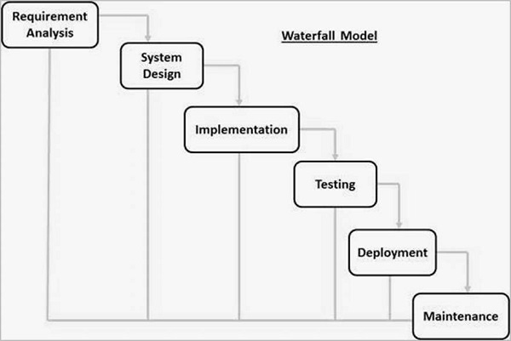

Figure 1:WATERFALL MODEL

In requirement gathering and analysis, the study adopted a survey-based research design which was the most efficient for solving the research objectives. This design involves collecting data from a sample of Jiinue SACCO members, staff and management using questionnaires and interviews. The survey will aim at identifying the challenges Jiinue Youth SACCO faces, the satisfaction levels of the users of the current system and their expectations for a new management system.

The survey design was effective due to several reasons:

1. It is cost effective and efficient since data can be collected from a large sample of the SACCO’s members, staff and management within Mathari within a short time.
2. It provided quantitative data that can be analyzed statistically to answer the research questions created.
3. It gave first-hand information and the satisfaction levels of the users of the current system and what they expected with the new system.

When designing the survey, the questions were valid, reliable and should address the research questions and objectives. It was also pilot tested to ensure the questions are relevant to the target audience.

In spite of carrying out a survey being the most effective research design, it had some challenges such as low response rate from several players in the system. Analysis of the survey may also have some issues especially if the data was complex or there was inconsistency of the information provided.

## 3.3: Research Design

The main problem is to determine the factors that contribute to the success of failure of the youth SACCO. The research questions we came up with are:

1. What factors contribute to the success or failure of the youth SACCO?
2. What challenges are faced by the youth SACCO in providing financial services to their members?
3. What strategies are we needed to come up with in order to overcome these challenges?

We decided to use the experimental design whereby we will integrate changes in the running of the SACCO that is from the manual processes to an electronic process. In this method we will be able to observe if the independent variable integrated will showcase a positive or negative effect on the dependent variable that is the SACCO and its members.

We will also empower the youth as a plus service that comes with joining the SACCO. This will be a successful outcome because we will bridge the defect that comes with the digital lenders institutions that don’t show the youth how they will invest the money they get. We will also allow the youth do make a deposit to their savings account anytime because we understand the youth have different jobs with limited range of offering.

## 3.4: Data collection

To be able to know well about the youth SACCO we reached out to the youths in Mathari to get their views. The method we used to collect data include administering questionnaires, interview, document analysis and observation.

## 3.5: Population

The approximate population of youths in Mathari sub-county is 50,000. From the document analysis done in the SACCO the number of registered members of Jiinue Youth SACCO is 3,700.In the 3,700 registered members those active are 1,400

## 3.6: Sample size and Sample Procedure

We aim on representing the youths in the area as well as the members of the SACCO. To enable a more accurate data we decided to do a large sample size as the study aims to get information on the total running of the SACCO from registration to loan disbursement.

Sample procedure:

To ensure that the sample in representative of the entire youth SACCO members, a random sampling procedure can be used. In this case each member of the youth SACCO has an equal chance of being selected to participate in the research.

Alternatively, a stratified random sampling procedure can be used to ensure that the sample includes demographic groups within the youth SACCO such as age, gender, occupation and geographical location. This ensures that the samples diverse and representative of the entire membership.

Both the sampling techniques we used are probabilistic sampling techniques where every unit in the population has a known and a non-zero probability of being selected. Stratified random sampling involves dividing the members into subgroups based on certain characteristics and then randomly selecting samples from each stratum in proportion to its size in the population. This approach ensures that the sample is representative of the population and reduces sampling errors.

In random sampling every unit of the population also has a n equal and non-zero chance of being selected. We used simple random sampling and it reduces the risk of bias and ensures that each member has an equal chance of being included in the sample.

## 3.7: Cost benefit analysis

To conduct the cost benefit analysis we had to identify the cost of setting up and the running of the SACCO which includes registration fee, rent, salaries and wages for the staff, marketing cost and any other operational cost.

We then estimated the expected benefits of the SACCO. This includes credit, savings, investment opportunities, social benefits and the financial management skills. We then assigned the cost and benefits a monetary value. We then calculate the Net present value(NPV),if the NPV is positive then the benefits outweigh the cost indicating that the SACCO is a viable and profitable investment.

## 3.8: Data collection tools

### 3.8.1:Administering questionnaire

We administered the questionnaire in two ways online and in-person. The questionnaire questions were as follows:

**The response to this questionnaire will assist us know your view on the current running of Jiinue Youth SACCO in Mathari Sub-county**

**Please tell us a little about yourself**

NAME:……………………………………

PHONE NUMBER:……………………………………

1.What is your age:

* 18-25
* 26-35

2.How did you hear about the youth SACCO?

……………………………………………………………………………………………………………………………………………………………………………………………………………………………………………………………………………………………………………………………………………………………….

3.How long have you been a member of Jiinue Youth SACCO?

* Less than a year
* 1-3 years
* 3-5 years
* More than five years

4.Have you ever applied for a loan in the youth SACCO?

………………………………………………………………………………………………………………………………………………………………………………

5.If yes what was the purpose of the loan?

* Educational
* Business
* Personal expenses
* Other(please specify)

……………………………………………………………………………………………………………………………………………………………………………………………………………………………………………………………………….

6.On a scale of 1-5 how satisfied were you with the loan application process?

* 1-very dissatisfied
* 2-dissatisfied
* 3-neutral
* 4-satisfied
* 5-very satisfied

7.How satisfied are you with the services offered by the youth SACCO?

* 1-very dissatisfied
* 2-dissatisfied
* 3-neutral
* 4-satisfied
* 5-very satisfied

8.Have you attended any training or workshop organized by the youth SACCO,if yes how useful was the training or the workshop?

……………………………………………………………………………………………………………………………………………………………………………………………………………………………………………………………………….

9.What challenges do you face as a member of the youth SACCO?

………………………………………………………………………………………………………………………………………………………………………………………………………………………………………………………………………………………………………………………………………………………………

10.What suggestions do you have for improving the services and operation of the youth SACCO?

………………………………………………………………………………………………………………………………………………………………………………………………………………………………………………………………………………………………………………………………………………………………

THANK YOU FOR TAKING YOUR TIME TO FILL THIS QUESTIONNAIRE.

### 3.8.2:Document analysis

We read through documents such as the SACCO’s financial statements, policies and procedures and annual reports that provide useful data on Jiinue Youth SACCO’s performance and operation.

### 3.8.3:Observation

Observing the youth SACCO’s activities and processes provided valuable data on the operations of the youth SACCO including the process for loan disbursement, member’s engagement and financial management.

### 3.8.4:Interview

We interviewed the SACCO management to learn more on how the SACCO is currently being run. The interview question used are as follows:

**Interview questions for the management to understand the current running of Jiinue Youth SACCO**

**POSITION: Management**

1.Greet the candidate and introduce myself with my full name and what I intend to interview them about.

2.Ask for their name.

3.How are you today?

4.Explain a bit about Jiinue youth SACCO and its objectives?

5.What financial products and services do you offer and how is the process is carried out?

6.How does the SACCO ensure that its services are accessible and affordable to all members including those in low-income communities?

7.What measures does the SACCO put in place to manage risks and ensure the financial sustainability of the organization?

8.Can you describe any challenges or obstacles the SACCO has faced in achieving in achieving its mission and how do you address them?

9.Can you discuss any future plans or initiatives that your SACCO has in the works, such as expanding services or entering new market?

10.Finally, how does your SACCO differentiate itself from other financial institutions in the market and what do you see as your unique value proposition to members?

11.Thank the candidate for their time

## 3.9:TEST,RETEST AND DATA RELIABILITY

### 3.9.1: testing and reliability of the tools

Determines the consistency of the data tools and data collected.

Testing methods:

1. Test-retest: involves administering the same test or measurement to the same group of participants on two different occasions separated by a period of time. Is used to determine whether a test produces consistent results over time.
2. Internal reliability: it is basically looking at the consistency of people’s response.

### 3.9.2: presentation of data

Is a representation of collected data from the various data collection tools.

The following data presentation methods are used:

1. Dashboards: provide a visual representation of key performance indicators and other important data. Can be customized to display information such as loan performance, savings and deposit balances.
2. Reports: provide detailed information on various aspects of SACCO operations. can be created to display information such as member details, loan and savings balances, loan origination and approval rates.
3. Geographic information systems (GIS): GIS too;s can be used to present data on a map which can be helpful for analyzing the distribution of members , loan performance and other geographical data.

# CHAPTER FOUR: SYSTEM ANALYSIS AND DESIGN

## 4.1:INTRODUCTION

System Design is the process of planning a new business system or replacing an existing system by defining its components or modules to specify the specific requirements. This was achieved by developing the system architecture after gathering system requirements; context diagrams, use case for system user system interactions capture, system design methods and data analysis.

## 4.2:REQUIREMENTS

### 4.2.1:Functional Requirements

The functional requirements of the system are:

1. The system should allow for easy registration of new members and management of their profiles.
2. The system should allow members to save money, track their savings and withdrawal activities.
3. The system should allow members to apply for loans and view their loan balances.
4. The system should allow effective communication between the SACCO and its members such as sending notifications.
5. The system should ensure the confidentiality and integrity of the member’s information.

### 4.2.2:Non-functional Requirements

The non-functional requirements are:

1. A person must have a National ID to be able to register to join the SACCO
2. Loans are to be given to someone who has saved a minimum of six months.
3. The system should be reliable at all times with appropriate recovery procedures.
4. The system should be secure with appropriate measured in place to protect sensitive members and financial data.
5. The system should be able to integrate with other systems and application used by the SACCO.

## 4.3:Process design

### 4.3.1:Usecase Diagram

**Usecase diagram for Jiinue Youth SACCO**

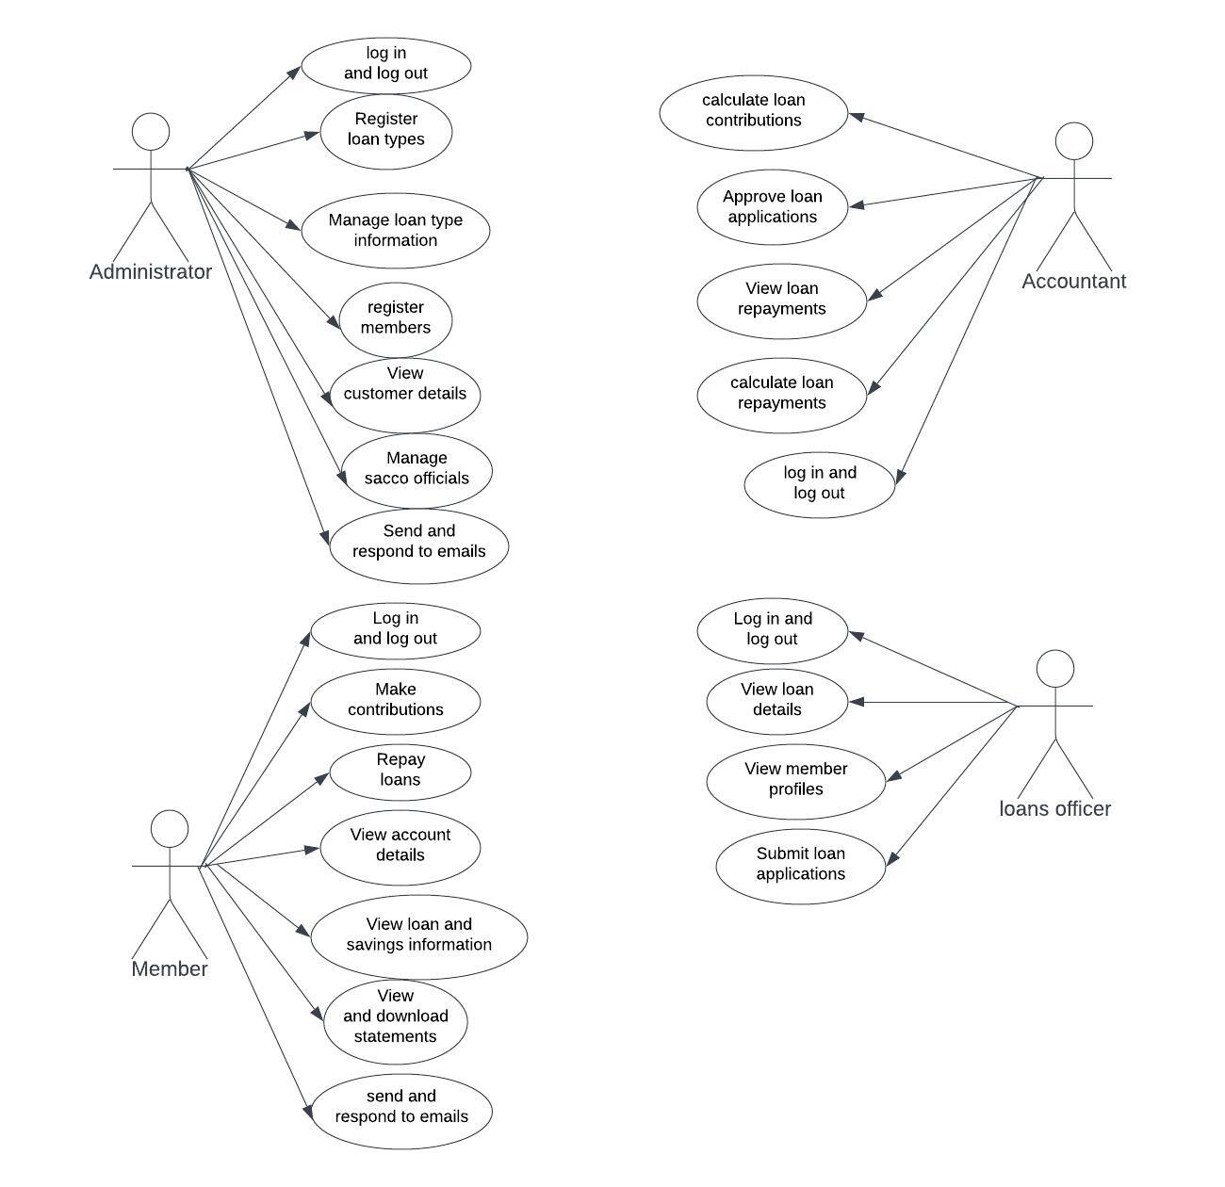

Figure 2:USECASE DIAGRAM

### 4.3.2:Activity diagrams

**1) SACCO member**

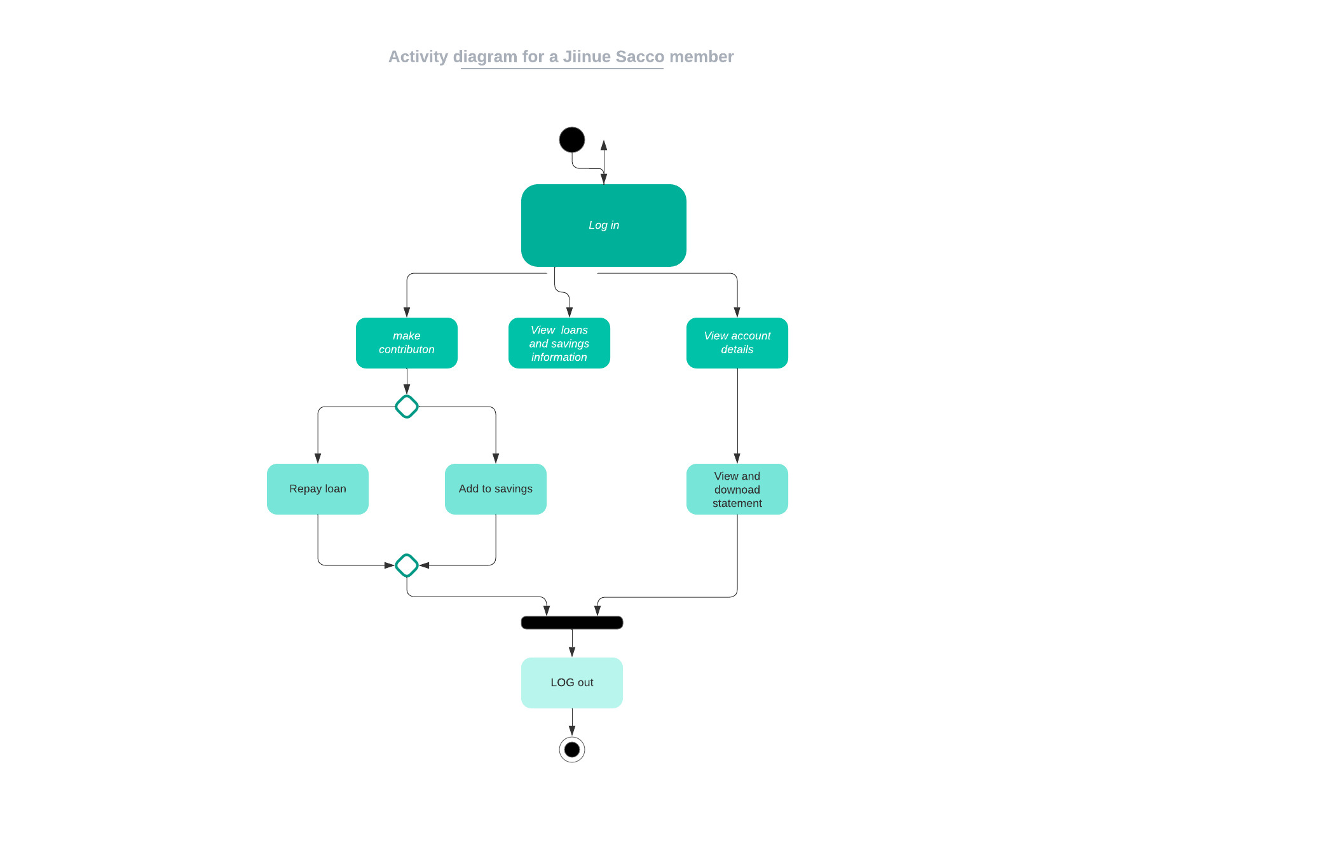

Figure 3:SACCO MEMBER ACTIVITY DIAGRAM

**2) SACCO Administrator**

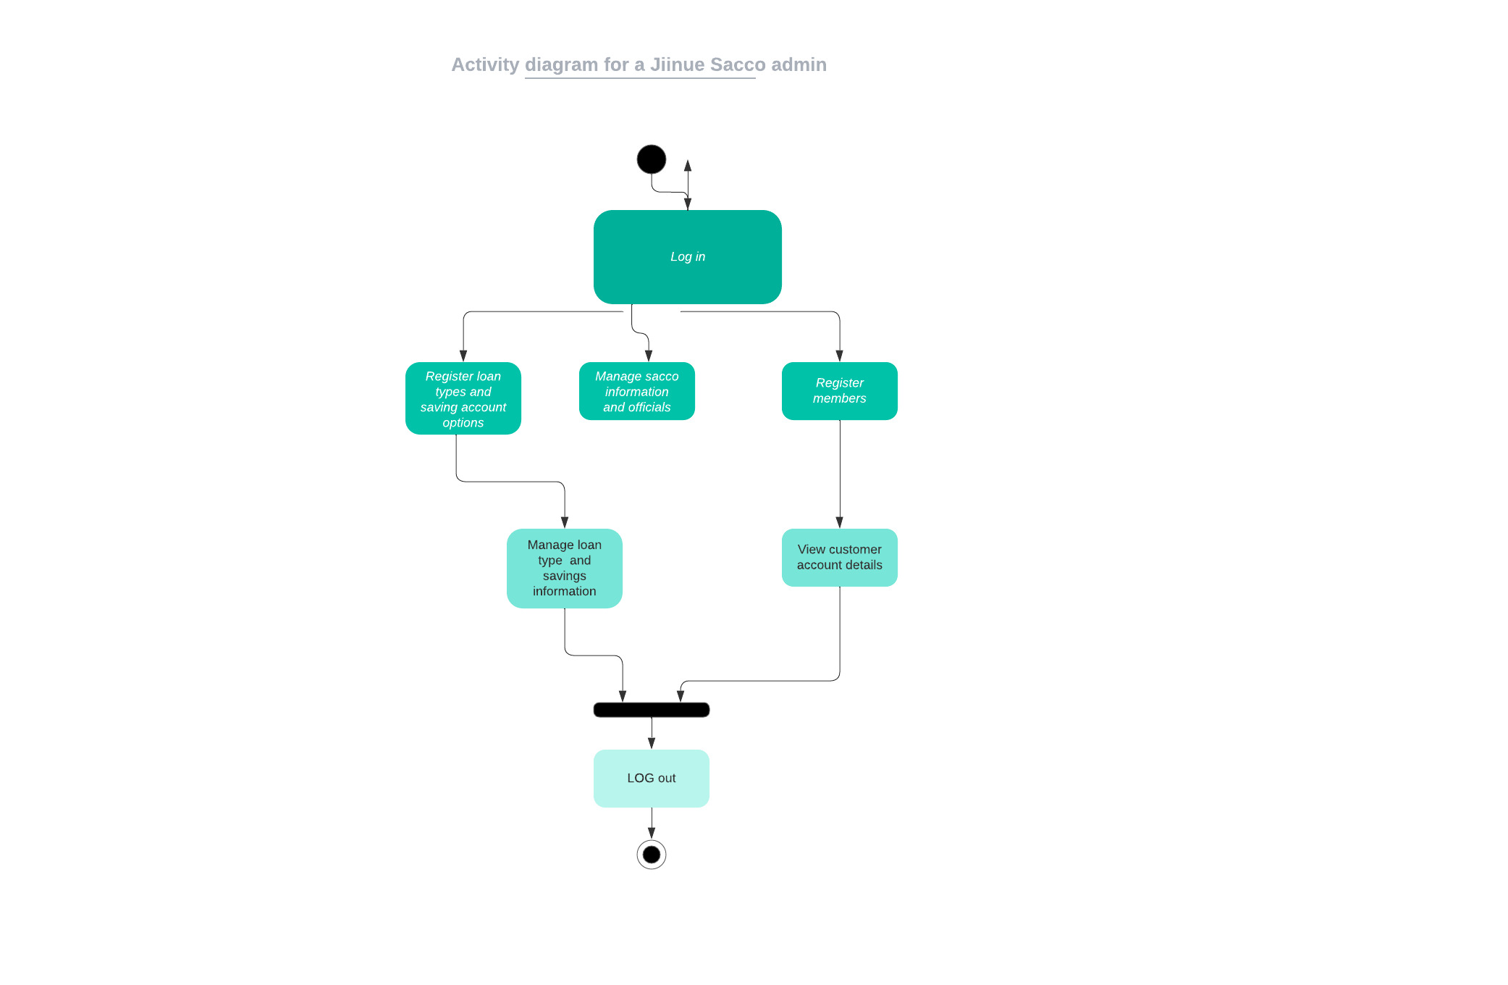

Figure 4:SACCO ADMINISTRATOR ACTIVITY DIAGRAM

### 4.3.3:Flowchart

**FLOWCHART TO REPRESENT HOW ONE CAN SIGN UP**

**Yes**

Already have an account?

Proceed to enter your full name

Log in

**No**

Wait for response from the page

Create Password

Enter MPesa Number

Enter Phone Number

ID Number

Enter Email

Figure 5:FLOWCHART 1

**FLOWCHART TO ILLUSTRATE HOW A MEMBER CAN SAVE IN THE SACCO**

Go to dashboard

Wait for feedback from the page

Connect to your MPesa menu

Enter the amount to save

Click on the ‘’Save’’ button

Figure 6:FLOWCHART 2

**FLOWCHART TO ILLUSTRATE HOW A MEMBER CAN BORROW A LOAN FROM THE SACCO**

Wait for feedback from the page

Acquire loan?

Eligible?

Proceed to loan calculator

Click the ‘’Borrow Loan’’ button

Enter the amount to borrow

Proceed to dashboard

**No**

**Yes**

**No**

**Yes**

Figure 7:FLOWCHART 3

# CHAPTER FIVE: TESTS AND RESULTS

## 5.1:INTRODUCTION

This chapter includes information about the various tests that were conducted during the development process and the results that were obtained from these tests. This chapter is important because it allows stakeholders to understand how the SACCO website was developed and to see the evidence that the SACCO is functional and effective. After doing research on the types of testing, our group settled on the functional testing method. Functional testing is a type of testing that seeks to establish whether each application feature works as per the softwarerequirements. Each function is compared to the corresponding requirement to ascertain whether its output is consistent with the end user's expectations.

## 5.2:FUNCTIONAL TESTING

### 5.2.1:TEST CASE 1

Purpose: To demonstrate successful creation of an account

Procedure

1. Open the SACCO's registration page.
2. Click on the "Create an Account" button.
3. Fill out the registration form with valid information, including a unique username, a valid email address, and a secure password.
4. Click on the "Submit" button to submit the registration form.
5. Verify that a confirmation message is displayed indicating that the account was successfully created.
6. Verify that the user is redirected to the login page.
7. Enter the registered username and password in the login form.
8. Click on the "Login" button.
9. Verify that the user is logged into the account dashboard.
10. Verify that the user's account information is displayed accurately in the dashboard.

Results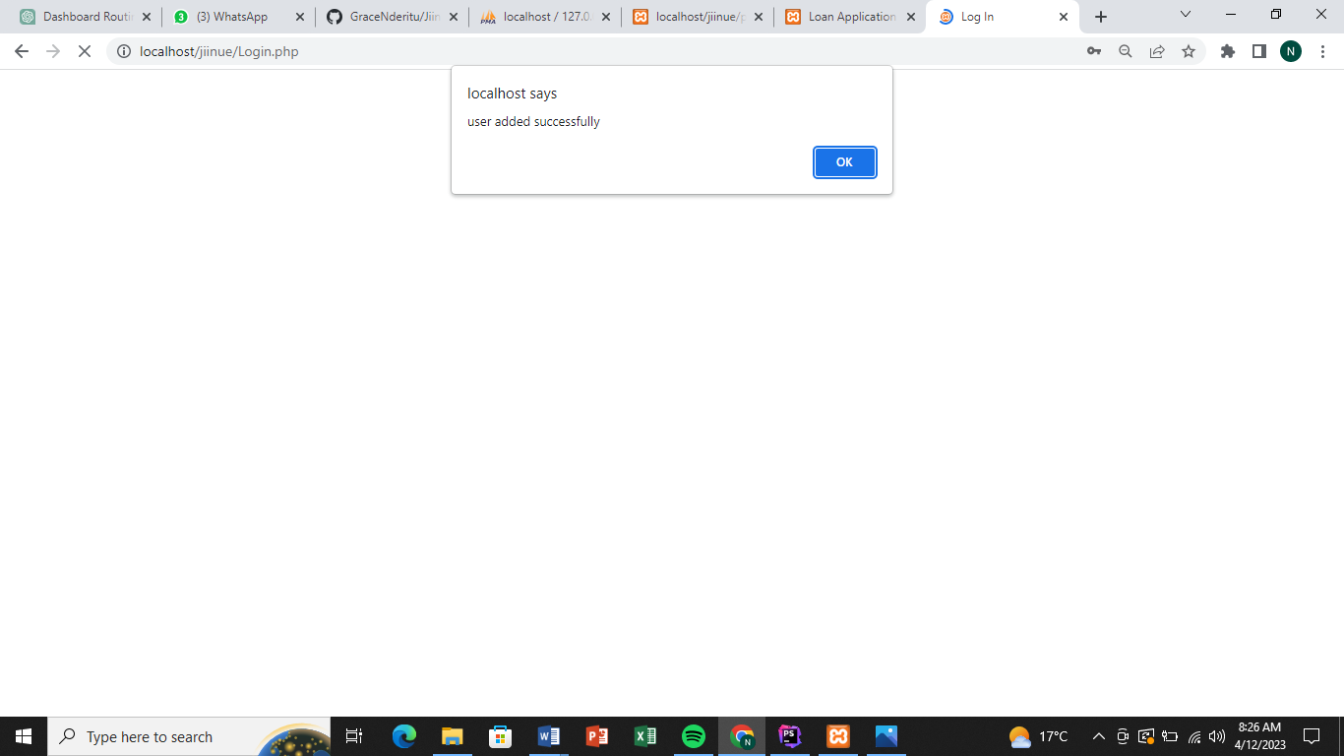

Figure 8:SUCCESSFUL REGISTRATION

Verdict

By conducting such test cases, you can ensure that the account creation process of the youth SACCO works as intended and is user-friendly for the members.

### 5.2.2:TEST CASE 2

Purpose: To show a successful login

Procedure

1. Open the SACCO's login page.
2. Enter a valid username and password that belong to an existing account.
3. Click on the "Login" button.
4. Verify that the user is redirected to the account dashboard.
5. Verify that the user's account information is displayed accurately in the dashboard.
6. Verify that the user has access to all features and functions that are available to members.

Results

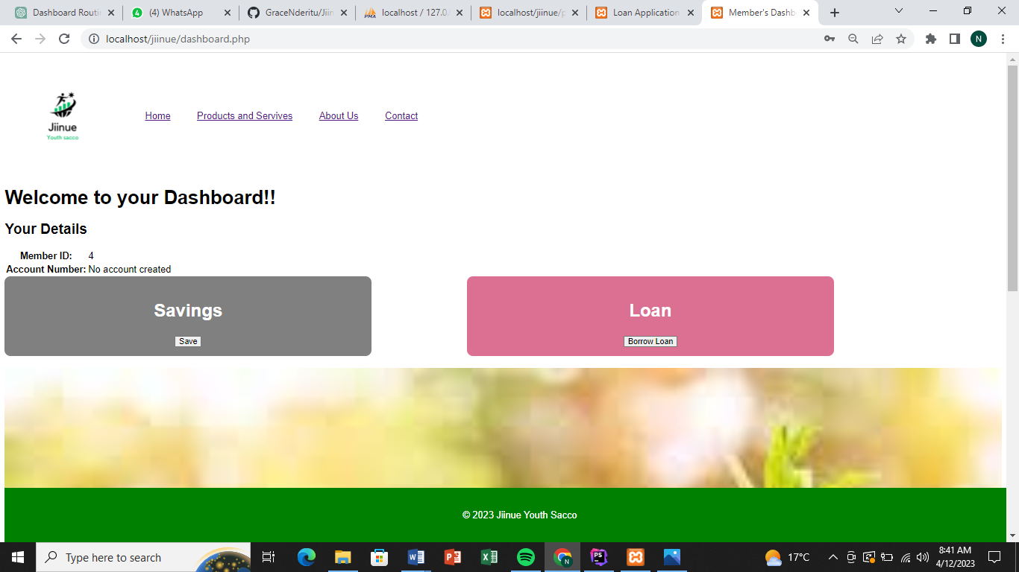

Figure 9:SUCCESSFUL LOGIN

Verdict

By conducting such test cases, you can ensure that the login process of the youth SACCO works as intended and provides secure access to member accounts.

### 5.2.3:TEST CASE 3

Purpose: to test the loan application process

Procedure

1. Open the SACCO's loan application page.
2. Click on the "Apply for a loan" button.
3. Fill out the loan application form with valid information, including the loan amount, repayment period, and purpose of the loan.
4. Click on the "Submit" button to submit the loan application.
5. Verify that a confirmation message is displayed indicating that the loan application was successfully submitted.
6. Verify that the loan application is recorded in the SACCO's loan application database.
7. Verify that the loan application is assigned a unique loan application number.
8. Verify that the loan application is sent to the SACCO's loan review team for further processing.
9. Verify that the loan application status is updated to "pending" in the loan application database.

Submitting multiple loan applications within a short period of time and verifying that only the first application is accepted, and the subsequent ones are rejected with an appropriate error message.

By conducting such test cases, you can ensure that the loan application process of the youth SACCO works as intended and is user-friendly for the applicants.

Results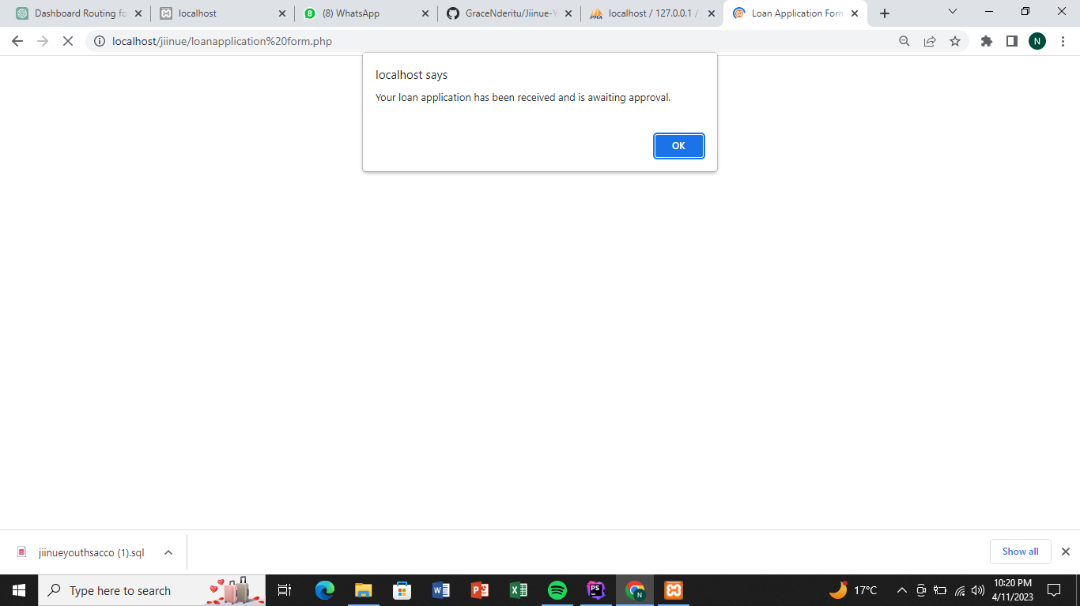

Figure 10:SUCCESSFUL LOAN APPLICATION

Verdict

Having filled all the details the member can apply for a loan.

### 5.2.4:TEST CASE 4

Purpose: To show a successful deposition into a savings account

Procedure

1. Log into the user's account dashboard.
2. Navigate to the savings account page.
3. Click on the "Deposit" button.
4. Enter the amount to be deposited into the savings account.
5. Select the source of funds for the deposit (e.g. bank transfer, mobile money, cash deposit, etc.).
6. Confirm the deposit details.
7. Click on the "Submit" button to initiate the deposit.
8. Verify that the deposit amount is credited to the user's savings account balance.
9. Verify that the transaction is recorded in the savings account transaction history.
10. Verify that the user's savings account balance is updated to reflect the deposited amount.

Results

Verdict

By conducting such test cases, you can ensure that the savings account deposit process of the youth SACCO works as intended and is user-friendly for the members.

# CHAPTER 6:IMPLEMENTATION AND DEPLOYMENT

## 6.1:Introduction

In this chapter we are looking at the steps to be followed once we have finished creating the website .What is required when we integrating the new system to replace the already existing one. We also look at how we are going to help the organization adapt to working with the new system.

## 6.2: Data conversion

1.Manual data entry

This method involves manually entering data to the new system. This method has a lot of limitations such as it is limited to small amount of data, slow and prone to errors. We will only use this method when the amount of data to be entered is small and we will also ensure to review the data entered.

2.Data export/import

This is the most recommended process for a large amount of data and it is much quicker than the manual process. This will only be able if the data to be exported is in the same format as what the system requires.

## 6.3: Implementation Strategy

We decided to go with the parallel changeover where there is a parallel running of the old and the new system simultaneously for a period of time. During this period, data and transactions are processed on both systems and the outputs are compared to ensure that the new is producing accurate results. This method will minimize the risk of any disruption and ensure a smooth transition from the old system to the new one. In the end the new system will gradually phase out the old system and when it is stable and accurate we will reduce the use of the old system until it is fully retired.

## 6.4: System Specification

We are to clearly stipulate the system objectives outlining the problems it will solve and the benefits it will provide. The system should define the specific functionalities such as member, loan and savings management. It should also define the non-functional requirement that must be met such as security, usability and reliability.

### 6.41: Hardware requirements

1.Computers: They should have sufficient processing power, memory and storage

2.Server: There should be a server to host the youth system also with sufficient processing power and storage

3.Printers: Printers should be selected based on the expected volume and type of printing required.

### 6.42: Software requirements

1.Security software: Security software such as antivirus and firewalls should be installed in the Jiinue Youth SACCO System to protect it from viruses and malware

2.Backup and recovery software: This software should be installed to ensure that data is protected and can be restored in case of data loss or system failure.

## 6.5: Support and Training

We will offer support and training through various methods such as printing user guides and manuals that offer comprehensive step by step instructions of the working of the system. We will offer a three weeks training period to ensure the users are comfortable and confident with the working of the system

# Chapter 7: Conclusion and Recommendation.

## 7.1:DISCUSSION

Jiinue Youth SACCO management system is a web-based application that helps automate the operations and management of the youth SACCO. The SACCO is a financial institution that promotes saving and provides credit services to its members. This project has helped us create ways in which members of the SACCO can access their accounts, save money in their accounts and get loans from the SACCO at ease without necessarily going to the branch offices.

The user interface design of the application is very user friendly and visually appealing, while also being efficient and effective for the SACCO staff and members to use.

The system’s features such as member registration, savings and loan management have been implemented effectively, enabling the SACCO to better serve its members and manage its financial transactions.

The SACCO management system has several strengths that fulfill the objectives of this project.

They include:

1. User-friendly interface that is easy to use for both staff members and members of the SACCO.
2. Automated processes such as registration and loan application that make it more convenient for members.
3. Strong security measures that ensure the overall security of the system and the users of the SACCO system.
4. A comprehensive database that is easy to read and retrieve data from.
5. Has improved member access to services provided by Jiinue Youth SACCO by making them available online.
6. Has also reduced manual errors that would have occurred if data was being filled manually.
7. The system will also be helpful in generating insights as to how the SACCO is running , through data analysis thus enabling the SACCO make data-driven decisions and monitor its financial performance.

## 7.2:Limitations

The project also faced some limitations, including technical challenges during implementation with the programming languages we had chosen and data quality issues. We also had a few issues with the database at first but we worked around the problem to create a better database that could accommodate all the data from the SACCO. These limitations may have impacted certain areas of the project such as the system’s functionality and the accuracy of the data recorded.

Despite these challenges, the project team was able to overcome them through proactive measures such as continuous testing and data validation processes and ensure the SACCO management system was running as it was supposed to.

The project team also learnt on the importance of planning early before executing ideas to prevent collision of ideas by various parties of the project team.

In spite of the SACCO system fulfilling most of the set objectives, we were not able to create a check-off system that would pay member loans directly through the employer. After much consideration we decided not to include the module into the system.

## 7.3:Recommendation.

Moving forward, there are opportunities for further enhancement of the system.

For instance:

1. Creation of the check-off system if the members are mostly employed that would help in loan repayment directly from the employer.
2. Regular system updates are necessary to ensure the system runs at optimum performance.
3. Continuous training sessions to ensure the system users are familiar with operations on the system.
4. Monitoring of data quality once in a while to ensure the system’s reliability and efficiency.
5. Integration with other software systems within the SACCO such as accounting software that may help in keeping member accounts in check.

## 7.4:Conclusion.

In conclusion, Jiinue Youth SACCO management system project has successfully implemented an automated solution the has improved the SACCO operations and member services.

Despite some limitations, the project has demonstrated its potential for enhancing the efficiency and effectiveness of SACCO management.

Future efforts could focus on further optimizing the system and leveraging its capabilities to drive greater member satisfaction and organizational growth in the ever evolving SACCO industry,

# APPENDIX

## Technical Requirements

### Hardware requirements

1. Intel core i3,i5 or i7 processor
2. 4GB RAM
3. 500GB Internal Hard disk
4. Laser jet printers

### Software requirements

1. Windows 8(and above) operating system
2. Microsoft Office (version beyond 2007)
3. Mobile device that can access the internet

## Project Timeline

1. Research and Analysis - 1 week
2. Design and Development - 5 weeks
3. Testing and Implementation - 1 week
4. Deployment and Training – 1 week

## Budget Cost Estimate

1. Software and hardware costs – 50,000 Ksh
2. Licencing and hosting costs – 30,000 Ksh
3. Maintenance and support costs- 30,000 Ksh

# REFERENCES

Tanzania Cooperative Development Policy (2012)

Cooperative Societies Act (2003)

Youth Savings and Credit Cooperatives

Financial Inclusion of Youth through Savings and Credit Cooperatives in Tanzania" by Naomi Martin (2018)

Youth Savings and Credit Cooperatives

Kenya Union of Savings and Credit Cooperatives (KUSCCO). (2017). Youth SACCOs: A guide to establishment and management. Nairobi, Kenya: KUSCCO.

Building Sustainable Youth SACCOs

Youth Savings Groups